# 

Team Members:

* **Ali Shoaib**
* **Muhammad Bilal**
* **Alyan Haider**

Instructor:

**Dr. Junaid Akhtar**

Contents:

Introduction: 5

Purpose: 5

Methodology: 6

Profitable Indicators: 6

Non-Profitable Indicators: 6

Results: 9

Profitable Indicators: 9

****Agriculture Land: 9

****Democracy Score: 10

****Exports: 11

****GDP per Capita: 11

****Literacy Rate Youth Total: 12

****Tax Revenue: 12

****Trade Balance: 13

****Income Per Person: 13

Unprofitable Indicators: 14

****Imports: 14

****Inflation: 15

****Poverty: 15

****Long-Term Unemployment Rate: 16

****Population Density: 16

Conclusion: 18

Abstract:

In this project we use the file named Gapminder, which contains the data of 227 different countries. on the basis of this Data, we rank the Countries on the basis of some Profitable indicators and some Non profitable indicators.

We tried our best to answer the question **“Pakistan Aisa Kyun Hai?”**



Introduction:

This project is about Pakistan overall condition in the whole world. We use the data of 227 different countries to explain that why the condition of Pakistan is like current situation. This project is based on the indicators like “Agriculture land, Income per person, Democracy, Literacy rate, Trade Balance”. Countries having high values of these indicators are ranked high because the economy of a country increases due to increase in the values of these indicators.

There are some other indicators like “Population Density, Imports, Inflation, Poverty and Long-Term Unemployment”. The countries having low values of these indicators are Ranked high. Because due to Increase in these indicators the Economy and Stability of a country decreases.

Purpose:

The purpose of this project is to answer the question “Pakistan Aisa Kyon Hai?” Being a Data scientist, one of the most important purposes is to prove the General statement of every politician with the help of our code and by using the data of every country. we have to prove that what is the reason of this current situation of Pakistan.

Methodology:

First of all, we read Gapminder excel file but it was not very helpful. Then being a Data scientist, we read the excel file with Pandas Library.

import pandas as pd

df = pd.read_csv(r'C:\Users\Muhammad Bilal\Downloads\Gapminder.csv')

myDataDict = {}

After reading the file we realized that there are very missing values in almost every column and we replaced the nan values with zeros. Every column represents each Indicator. we choose some profitable and some nonprofitable Indicators.

Profitable Indicators:

* Agriculture Land
* Income Per Person
* Democracy
* Literacy Rate Youth Total
* Trade Balance
* Tax Revenue
* GDP Per Capita
* Exports

Non-Profitable Indicators:

* Imports
* Inflation
* Poverty
* Population Density
* Long Term Unemployment Rate

Then we find the indices of each country in each column.

def Return_index(Countries, Country):  
 khali = []  
 for i in range(len(Countries)):  
 if Country == Countries[i]:  
 khali.append(i)  
 return(khali)

And also find the average of all given values of those columns for every country and replace it with missing values of those columns for every country. Then after replacing the missing values, we find the average of each column for each country.

def Replace_zero_with_avg(AgriDict, Country):  
 average = find_Avg_Without_Zero(Country)  
 lst = agriDict[Country]  
 for i in range(len(lst)):  
 if lst[i] == 0:  
 lst[i] = average  
 return (lst)

Then we find the maximum value for each column for each country and divide all the values of that column of that country with maximum value to normalize the data between -1 and 1. We do the same process for both profitable as well as nonprofitable Indicators.

After Normalizing the data, we sum the normalized data of all profitable indicator for each country. By doing this we get 1 value of each indicator for each country. We do the same process for nonprofitable indicators separately.

Then we sort the sum of normalized data in descending order for profitable Indicators. Then we rank the countries for profitable indicators.

def Sort_max_order(unSortedList):  
 max_sortedList = []  
 max_sortedIndices = []  
 for i in range(len(unSortedList)):  
 max_index = return_Index_max_in_list(unSortedList)  
 max_sortedList.append(unSortedList[max_index])  
 max_sortedIndices.append(max_index)  
 unSortedList[max_index] = -999999999  
 return max_sortedIndices, max_sortedList

After that we sort the sum of normalized data in ascending order for nonprofitable indicators. Then we rank the countries for nonprofitable indicators.

def Sort_min_order(unSortedList):  
 min_sorted_List = []  
 min_sorted_Indices = []  
 for i in range(len(unSortedList)):  
 minIndex = return_Index_Min_InList(unSortedList)  
 min_sorted_List.append(unSortedList[minIndex])  
 min_sorted_Indices.append(minIndex)  
 unSortedList[minIndex] = 10000  
 return min_sorted_Indices, min_sorted_List

We choose some countries to compare with Pakistan by plotting their graphs for profitable and nonprofitable indicators.

We choose ‘India’, ‘China’, ‘Afghanistan’, ‘Singapore’, ‘Bangladesh’, ‘Cyprus’, ‘Denmark’, ‘Bhutan’, ‘Mexico’, ‘Iran’ and ‘East Germany’.

And also plotted the graphs for each indicator.

Results:

Profitable Indicators:

Pakistan’s rank on the basis of “Agriculture land, Income Per Person, Democracy, Literacy Rate Youth Total, Trade Balance, Tax Revenue, GDP per Capita, Exports.” Is:

Countries rank 81 goes to: Pakistan with total Data of 1.443375029066

****Agriculture Land:

Being a backbone of any country’s economy agriculture plays an important role. Pakistan is an agricultural country and here its comparison with respect toother most stable and least stable countries of the whole world.

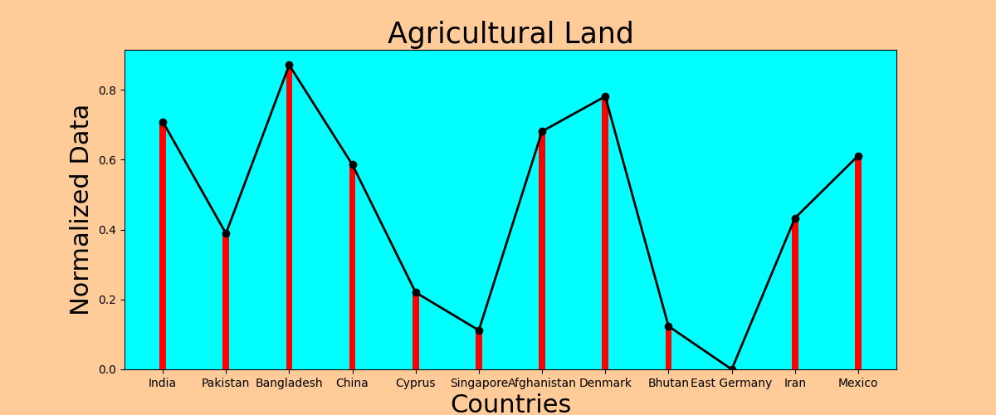

This agricultural land is the percentage per total area of that country. As Pakistan’s agricultural land is less than Bangladesh, India, China, Cyprus, Denmark and Afghanistan because a lot of agricultural land in Pakistan is not productive and useful because of lack of resources.

****Democracy Score:

Democracy is associated with higher population growth, inflation, lower political instability, and higher economic freedom. Democracy is closely linked to economic growth resources, such as levels of education and quality of life through the development of educational institutions and health care.

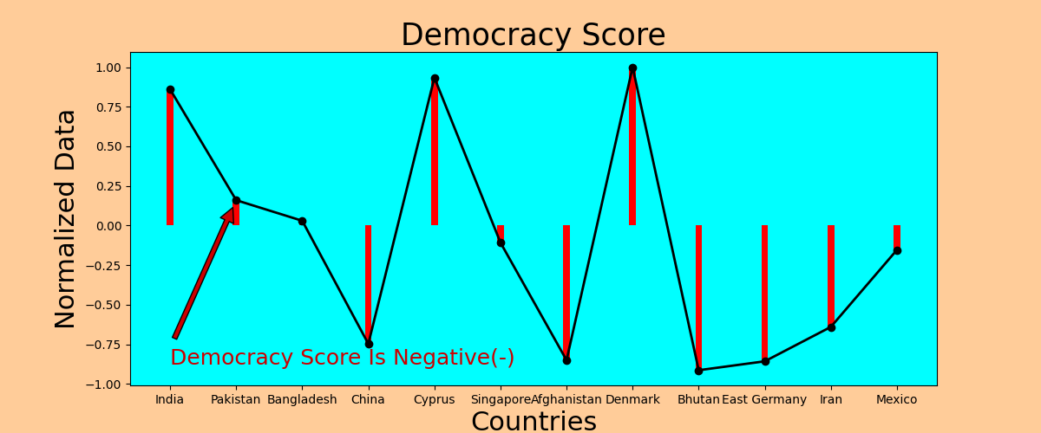

****Exports:

Rising exports will help increase AD and cause higher economic growth. Growth in exports can also have a knock-on effect to related 'service industries.

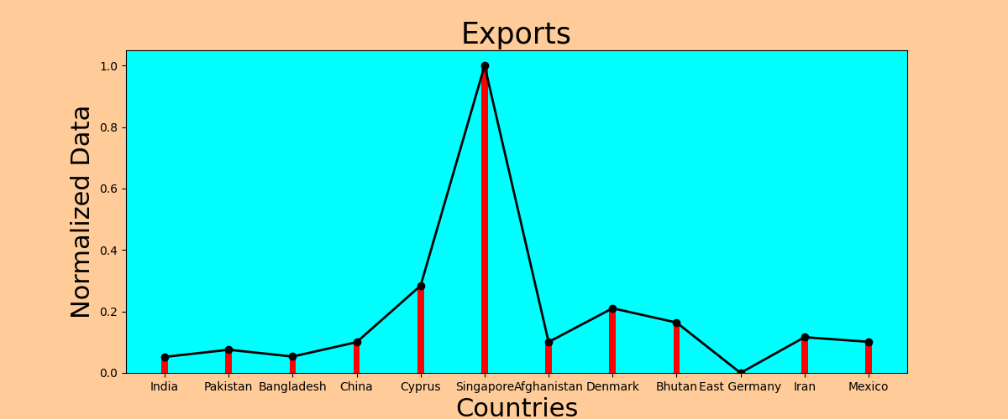

****GDP per Capita:

When GDP growth is strong, firms hire more workers and can afford higher wages and wages, resulting in more consumer spending on goods and services.

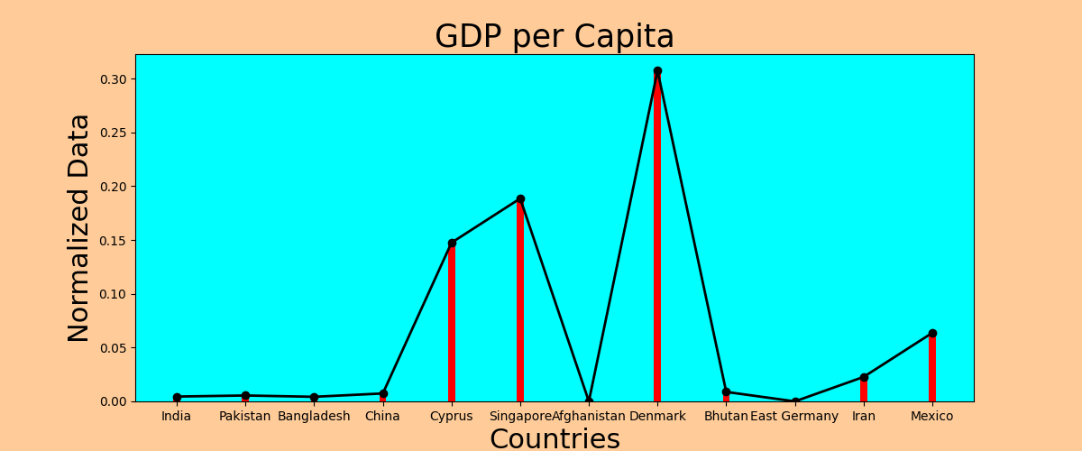

****Literacy Rate Youth Total:

A country with high literacy rates is more likely to attract a large number of investors and entrepreneurs as well as income which is a major contributor to the country's economy.

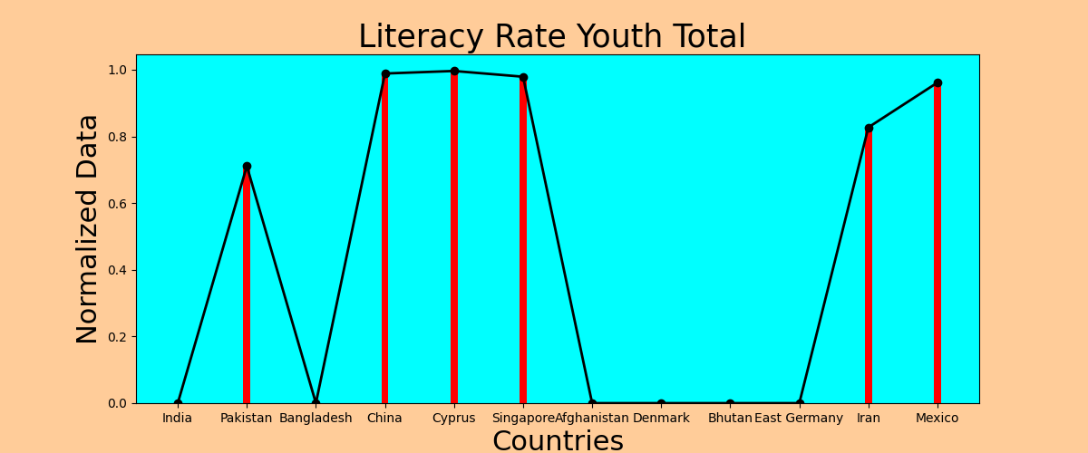

****Tax Revenue:

Tax revenue also effects the economy and stability of a country very much. The higher the tax revenue the best the country is.

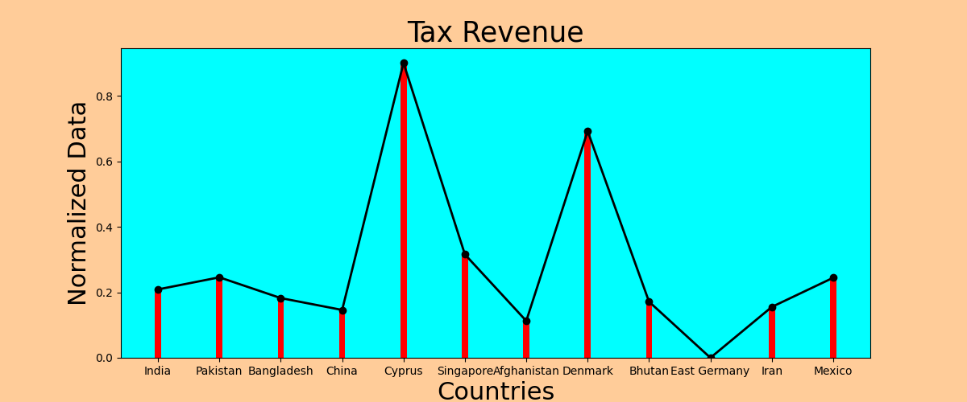

****Trade Balance:

Surplus Trade increases GDP, while trade deficits weaken it. Although most countries aim to find a favorable trading balance.

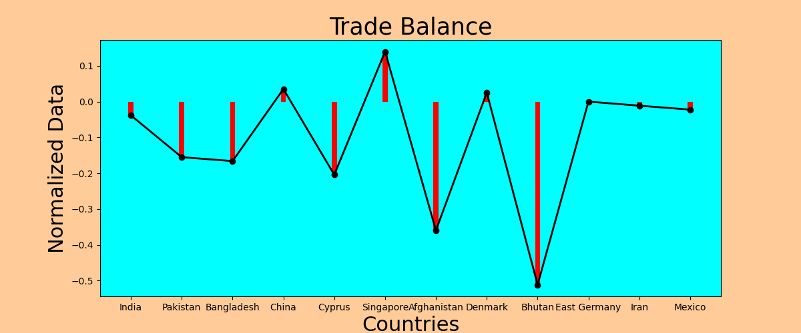

****Income Per Person:

Wages earning less increase faster than average wages. Economic growth creates jobs and reduces unemployment.

Income per person effects a lot on economic growth.

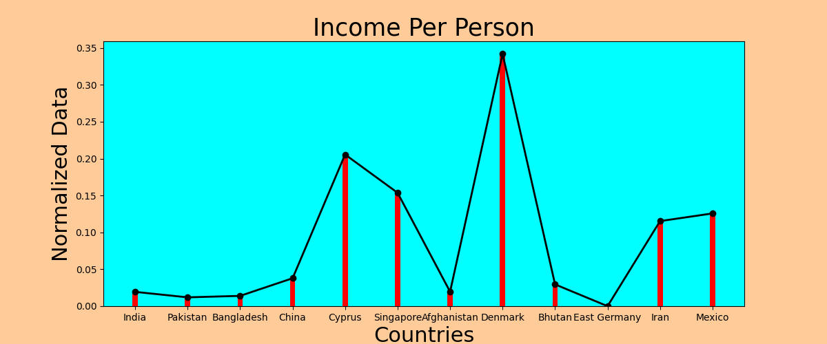

Unprofitable Indicators:

Pakistan’s rank on the basis of “population density, Imports, inflation, poverty and Long-term unemployment” is:

Countries rank 167 goes to: Pakistan with total Data of 0.7632982329410088

****Imports:

Imports affect a lot s for any country, because short-term gains will not guarantee long-term benefits for an individual economy.

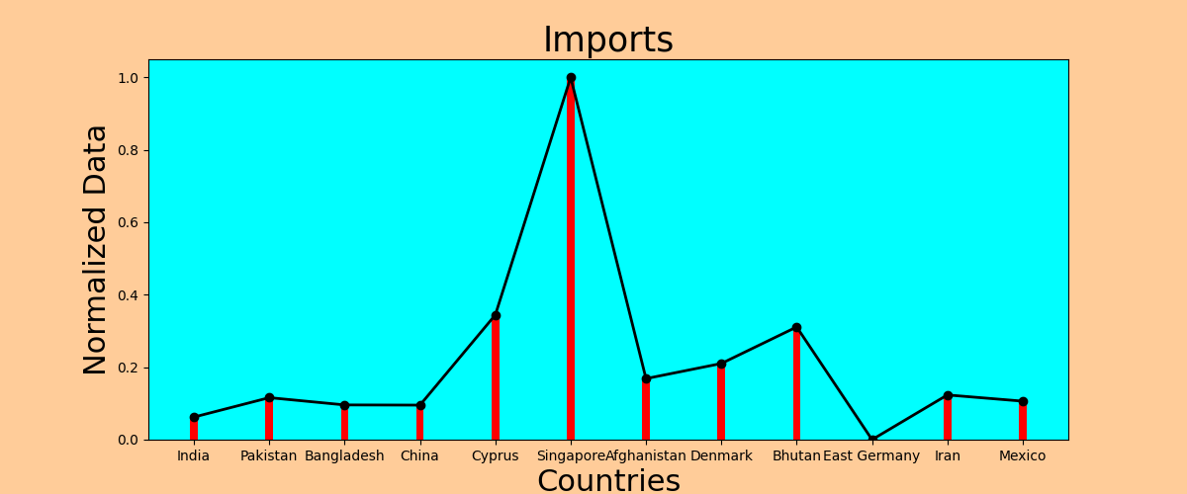

****Inflation:

When economy is not running at its best rate, one of the reasons behind this is Increase in Inflation Rate. An increase in the annual inflation rate of 10 percent per year reduces the real GDP growth by 0.2 to 0.3 percent per year.

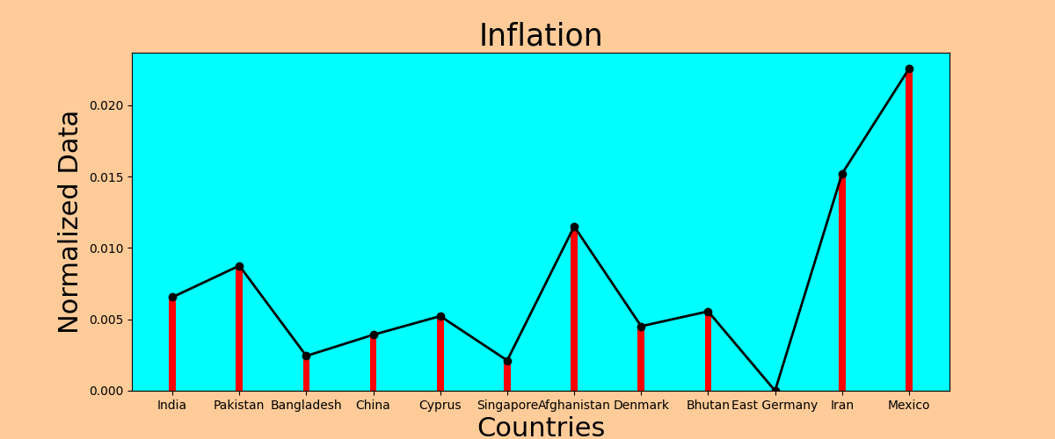

****Poverty:

When people are poor, they need money to live. Because of this, they are unable to invest in people, real money and their health. As a result, the economy effects a lot.

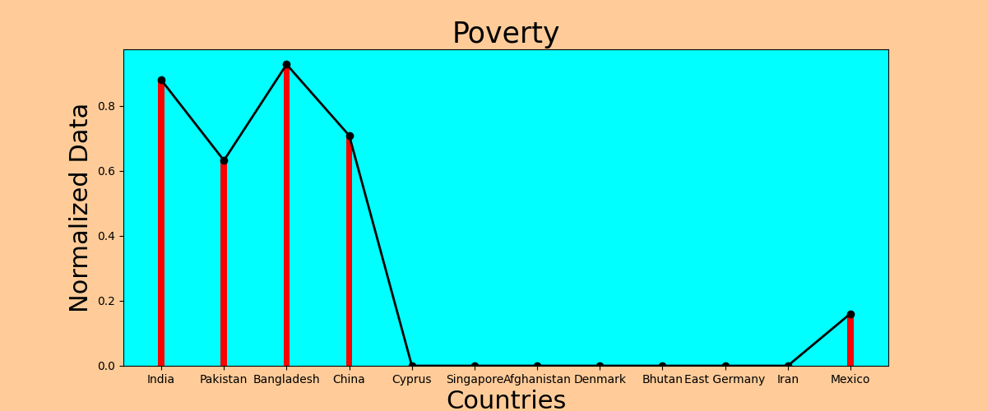

****Long-Term Unemployment Rate:

When unemployment rates are high and stable, there have negative impacts on long-term economic growth. Hence higher economy rate decreases.

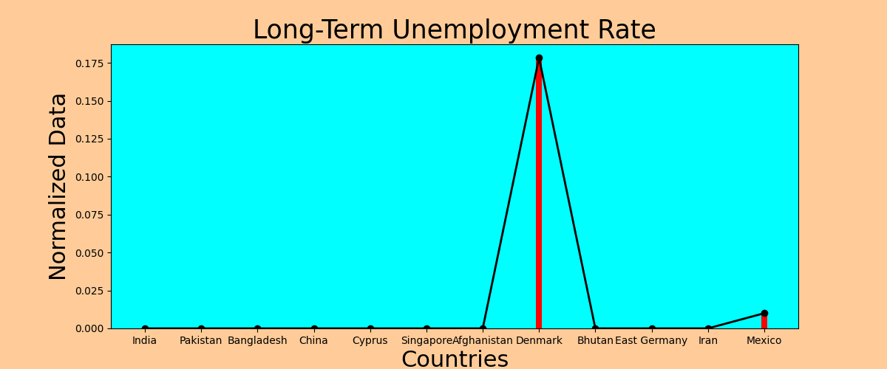

****Population Density:

As the population grows, the income per capita decreases. People need to feed more children with the same income. Increase in population increase in the use of resources. Increase in population affects economy a lot.

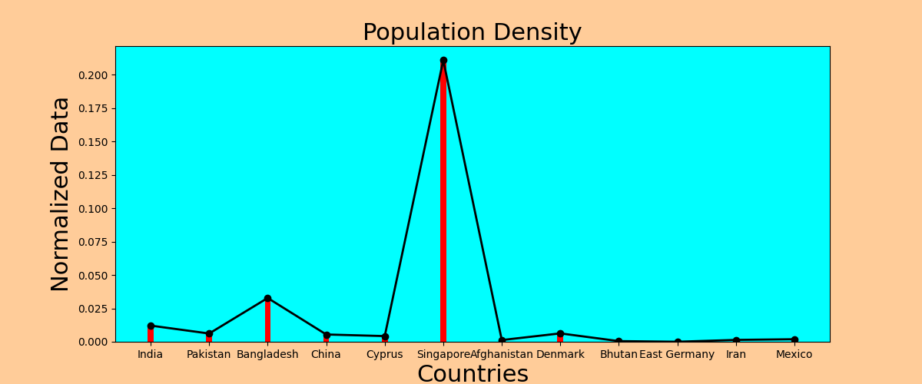

Conclusion:

Being a data scientist, we conclude that Pakistan’s rank in the overall world on basis of Profitable indicators is 81 among 213 countries which is not bad. But in “GDP, Agricultural land, Exports and Tax revenue”, Pakistan is very low as compare to developed countries. As Pakistan is an agricultural country but its agricultural land per total area is very low as compare to other countries. The large part of an area of Pakistan is not productive because of lack of water and other resources.

Pakistan’s rank in overall world on the basis of unprofitable indicators is 167 out of 213 countries which is very bad. It is because poverty and Inflation in Pakistan is very high due to which Pakistan economy is not good as compare to developed countries. All these are the reasons for Pakistan’s current situation. Being a data scientist, this is the best answer of the question “Pakistan Aisa Kyun Hai?”.